Proposal: Reinforcement Learning for Designing Robust Quantum Circuits
By
Charles Renshaw-Whitman c.r.whitman@student.tudelft.nl
Owen Huisman owen.t.huisman@icloud.com
Renze Suters renzesuters@protonmail.com

The aim of this project is to apply Reinforcement Learning (RL) to efficiently develop noise-resistant quantum-circuit implementations. In particular, while quantum coding focuses on developing robust universal implementations of QC hardware, it may be desirable to perform quantum computations using imperfect logical qubits and gates. The intent of this project is to explore the use of Reinforcement Learning to perform this task for small circuits (i.e. those which are classically tractable). More concretely, we will attempt to train an RL system which is capable of generating quantum circuits for the implementation of a simple algorithm (e.g. a 2- or 3-qubit implementation of Bernstein-Vazirani), out of imperfect gates and with qubits subject to decoherence. For an imperfect circuit, the RL system should be able to change the circuit until the circuit creates an output state that is 'close enough' to the target state. Currently, we consider implementing a neural network to form the backbone of the RL machine. The RL machine will be a classical actor, altering the circuit between runs (i.e. it will not be ‘in-the-loop’). See figure 1.
The goal will be the implementation of the circuit in the presence of gates subject to some ‘manufacturing’ noise distribution a priori unknown to the learner. Depending on the viability of this approach, qubits may also undergo various kinds of decoherence. Various simplifications or extensions to different noise-regimes are possible if the RL learner proves more or less difficult than expected.

Success criteria will be: Number of gates/resources used, and magnitude of noise/error withstood (‘withstood’ meaning producing an incorrect result with probability less than some preset ε). Time allowing (and assuming training is not so computationally intensive), it would be desirable to train a few models and attempt to plot the Pareto frontier of at least two of these criteria.

Extension: If the above success criteria were to be reached, an interesting extension of the algorithm could involve taking only state measurement results as input for the RL machine. The RL machine could then be implemented in an indirect measurement scheme, where the indirect measurements can be used such that the RL machine can provide feedback after a few circuit runs, which might allow for real time adaptations to noise. This would be a first step of hardware implementation of this idea, placing the learner ‘in-the-loop’ as an integral part of the experimental set-up.

Platform: Since we will choose the quantum circuit to be classically tractable, we will not need a quantum hardware backend. Instead, we would like to use the QiSkit simulator (Aer) for the project. This simulator allows us to program in Python, which means we could make use of TensorFlow and similar packages to do RL.

Reference: This work is inspired by work done by F. Marquardt’s group, discussed in this talk -
https://www.youtube.com/watch?v=2NH8Hphkt08
He discusses some implementation difficulties and workarounds for problems quite similar to this one.
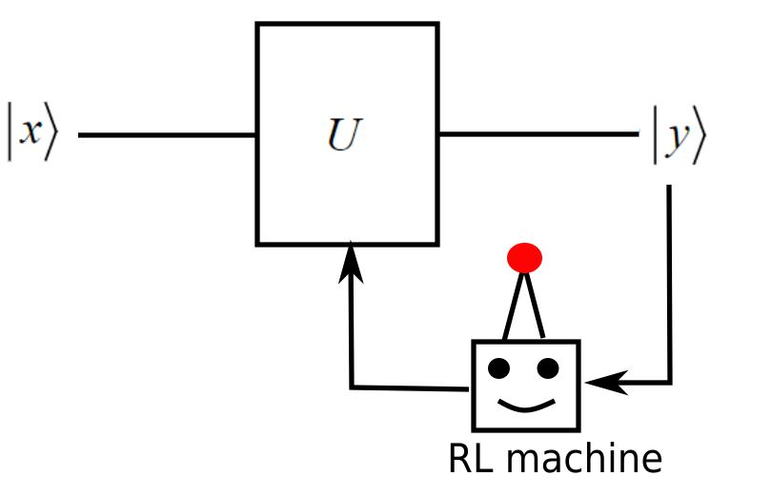

Fig. 1: schematic outline of proposed quantum circuit consisting of input , output and quantum unitary with the (classical) RL machine. The RL machine has absolute knowledge of the output state (the complete density matrix), and changes the quantum unitary based on how the output state deviates from the target .

